Task 3.2: Storing Data with Web Storage
Overview
In this task, I stored and retrieved data using web storage. Specifically, I did the following:
- Use sessionStorage to add items to the shopping cart as a part of the implementation of the “Add to Cart” feature on the Gallery webpage.
- Retrieve information about the added items in the shopping cart using sessionStorage as a part of the implementation of the “View Cart” feature on the Gallery webpage.
- Clear items from the sessionStorage as a part of the “Clear Cart” and/or “Process Order” features.
- Add customer feedback/custom order information to the localStorage from the web form in the About Us/Contact webpage.

Documented any issues or errors I encountered in my code development that prevented my stylesheet or webpages from functioning as intended.

Remembered, the component colors, font colors, and typography styling should be consistent with my choices in Task 1 and should be appropriate according to the client description provided in the client scenario and criteria.

Instructions
Provided responses in the following table.

Shopping Cart Items Screenshot

- The “View Cart” modal window should display the item information by reading from the sessionStorage.

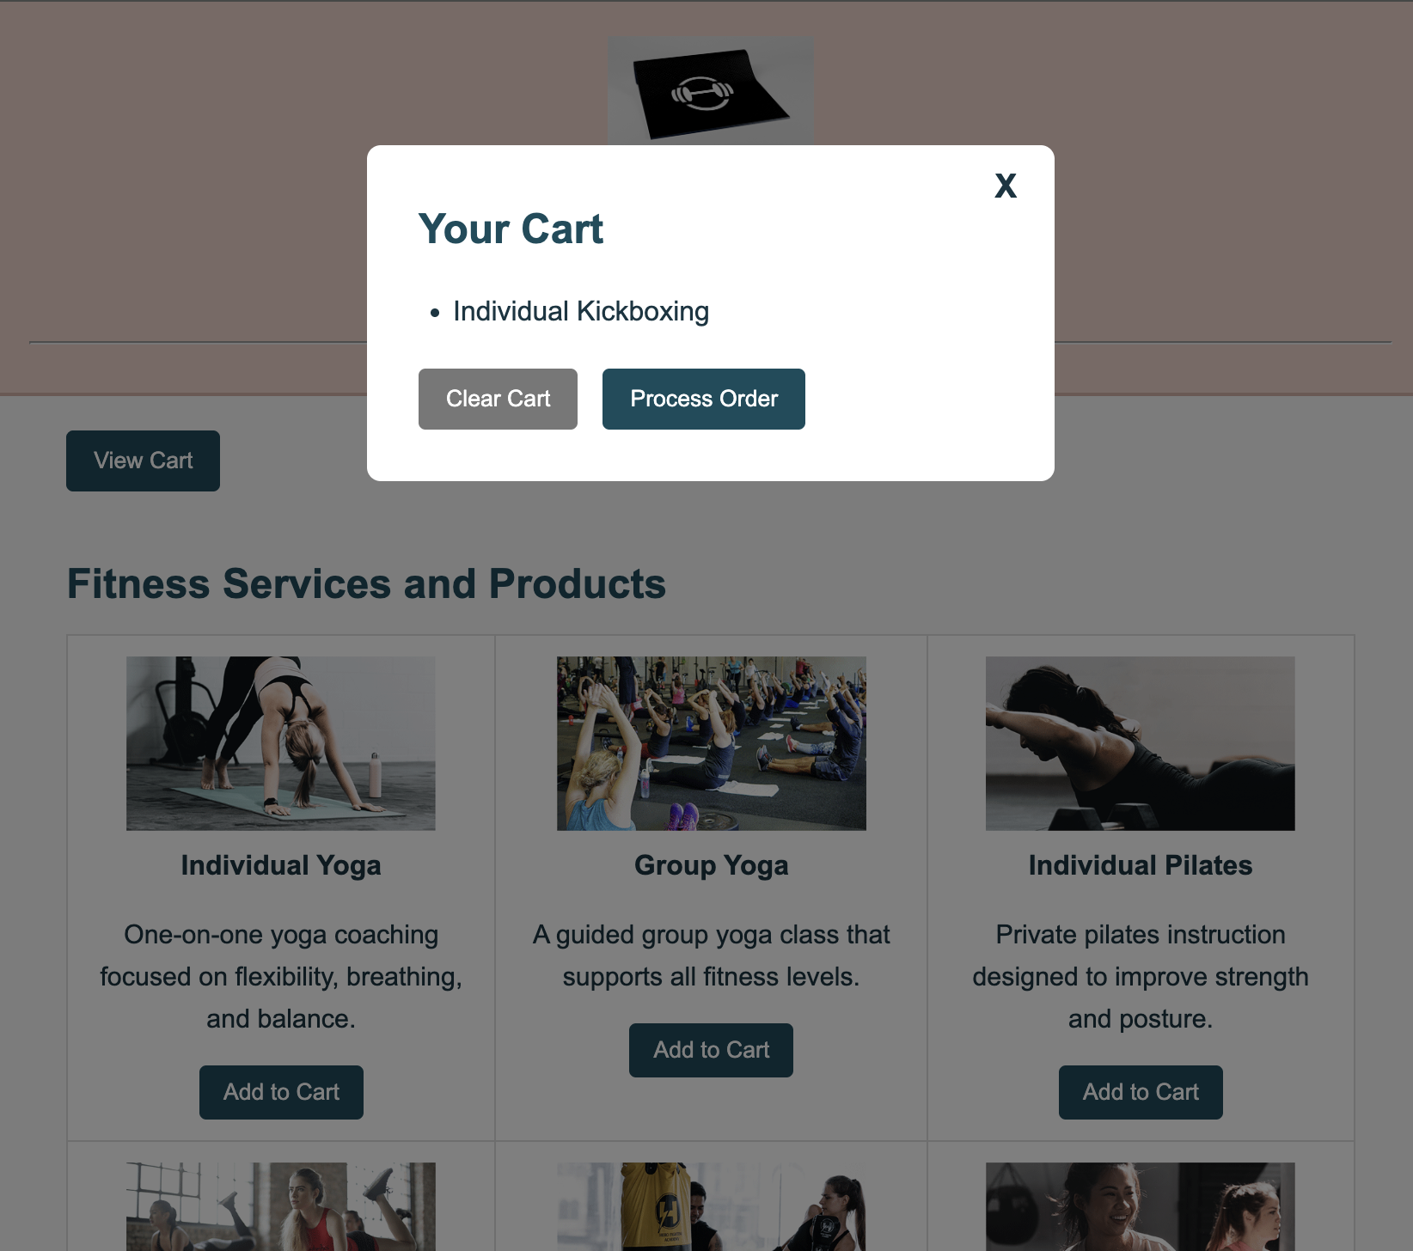

Shopping Cart Empty Screenshot

- The “Clear Cart”/“Process Order” button in the modal window should clear all the item information in the sessionStorage.

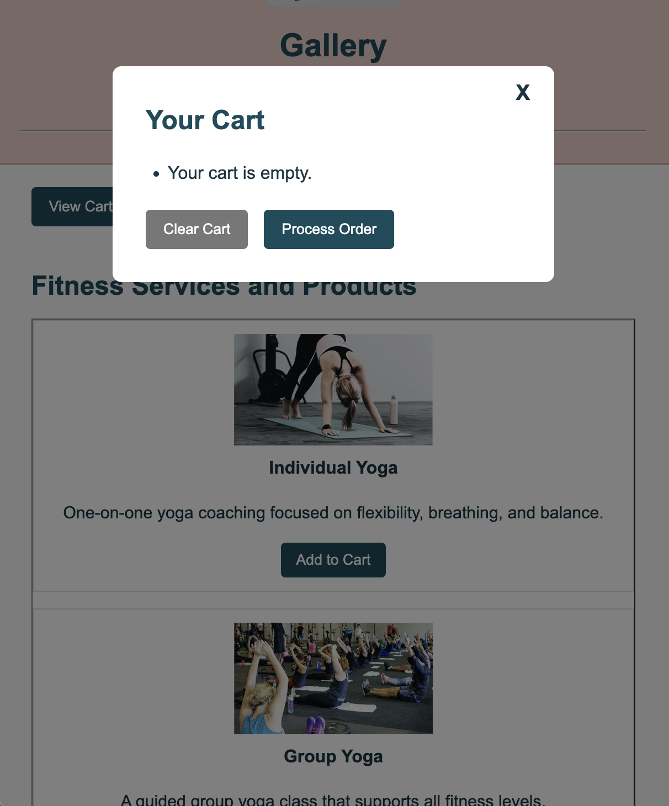

This screenshot shows the shopping cart window after the cart has been cleared using the “Clear Cart” or “Process Order” button. The cart displays the message “Your cart is empty,” confirming that all items have been successfully removed from the sessionStorage and the cart interface has updated accordingly.

Browser SessionStorage Screenshot (Before Clearing Items)

- The sessionStorage should show all the items currently added to the shopping cart.
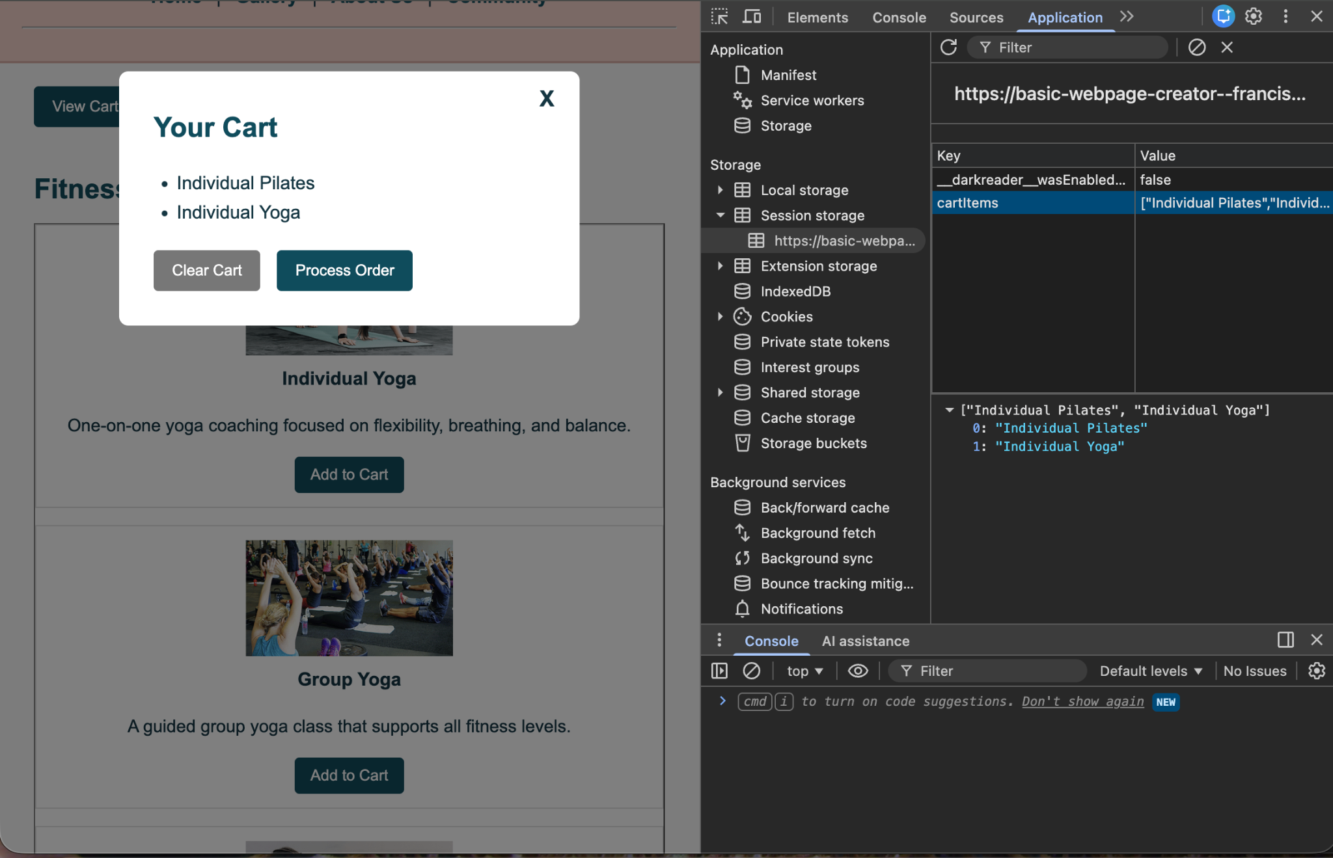
This screenshot shows the sessionStorage before the shopping cart has been cleared. The cartItems key is present and contains the items that were added to the cart, confirming that the selected products are being successfully stored in sessionStorage and retrieved by the cart functionality.

Browser SessionStorage Screenshot (After Clearing Items)

- The sessionStorage should be empty as all the items are removed from the sessionStorage.
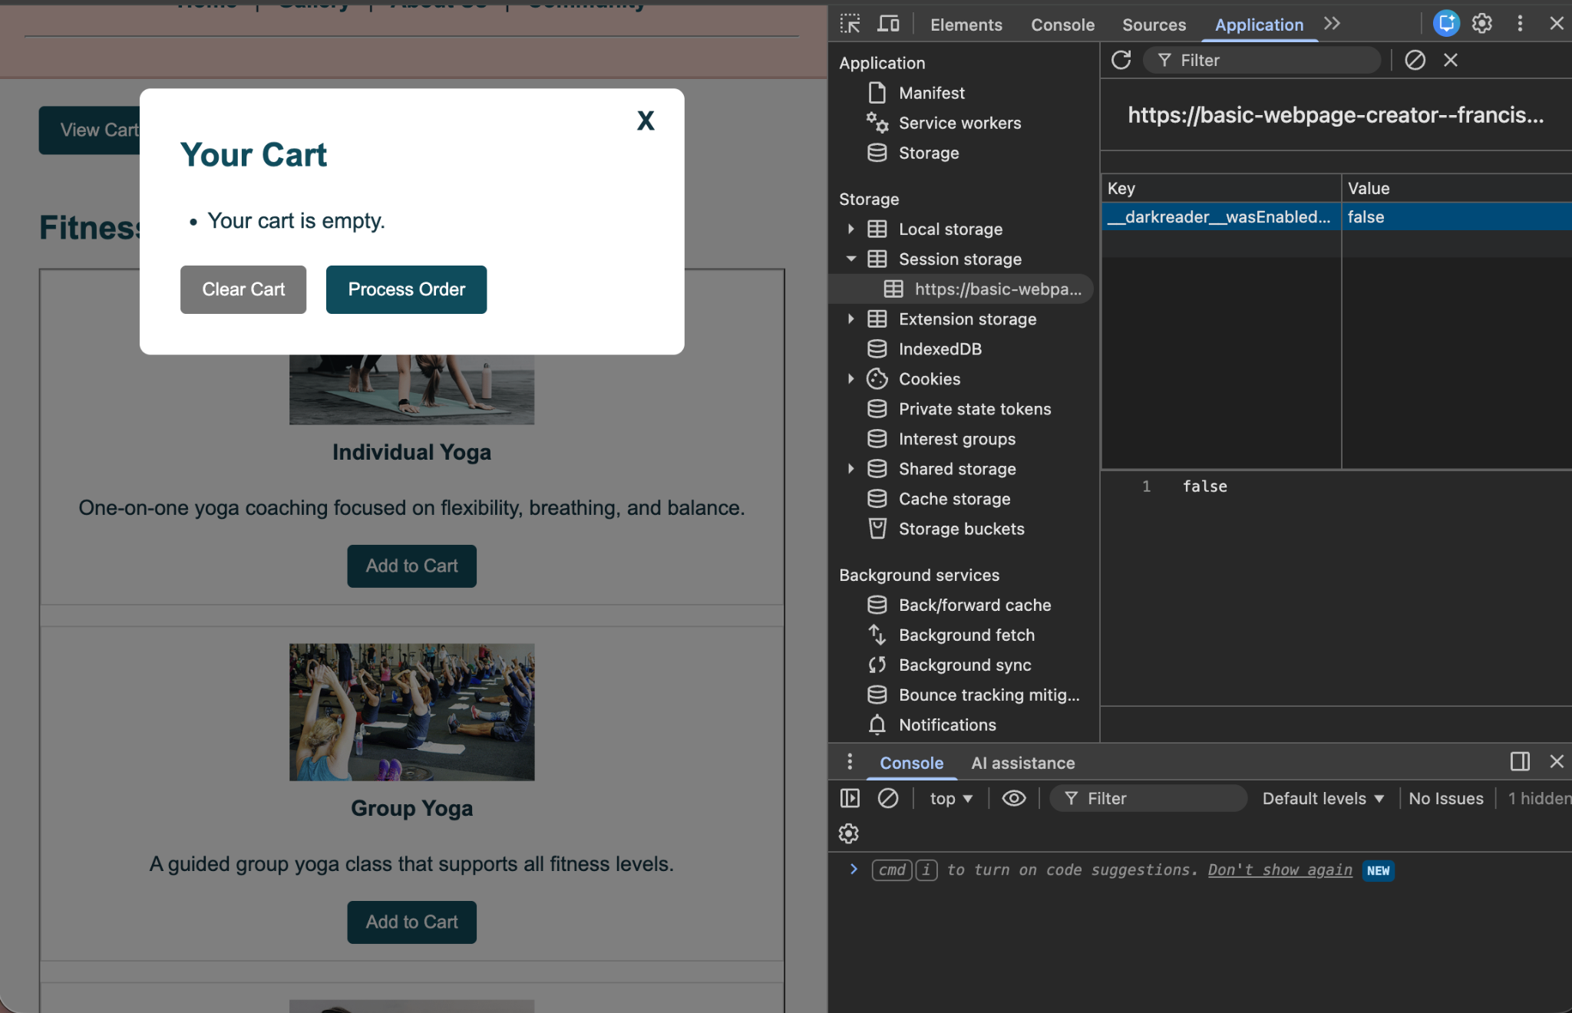

This screenshot shows the sessionStorage after the shopping cart has been cleared. The cartItems key is no longer present, indicating that all stored cart data has been successfully removed. The cart modal also displays that the cart is empty, confirming that the Clear Cart functionality is working as expected.

Shopping Cart Analysis
Each time an Add to Cart button is clicked on the Gallery page, the selected item is added to sessionStorage under the cartItems key. The View Cart feature reads the stored array from sessionStorage and displays the item names inside the cart modal window. The Clear Cart and Process Order buttons remove the stored cart data from sessionStorage, which leaves the cart empty.

Custom Order Screenshot

- Add custom order information to the localStorage from the web form in the About Us/Contact webpage.
- The custom order web form should save the customer information and feedback/custom order information in the localStorage.

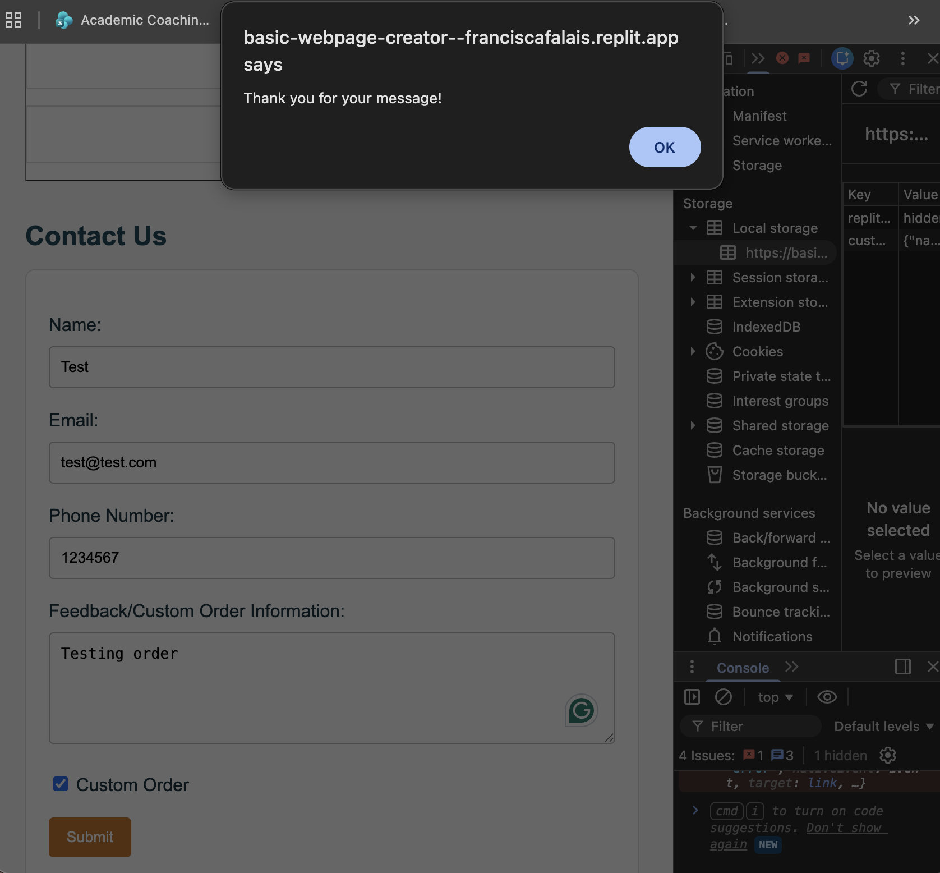

Browser localStorage Screenshot (After Submitting Form)

- The localStorage should display the customer information and the feedback/custom order information.
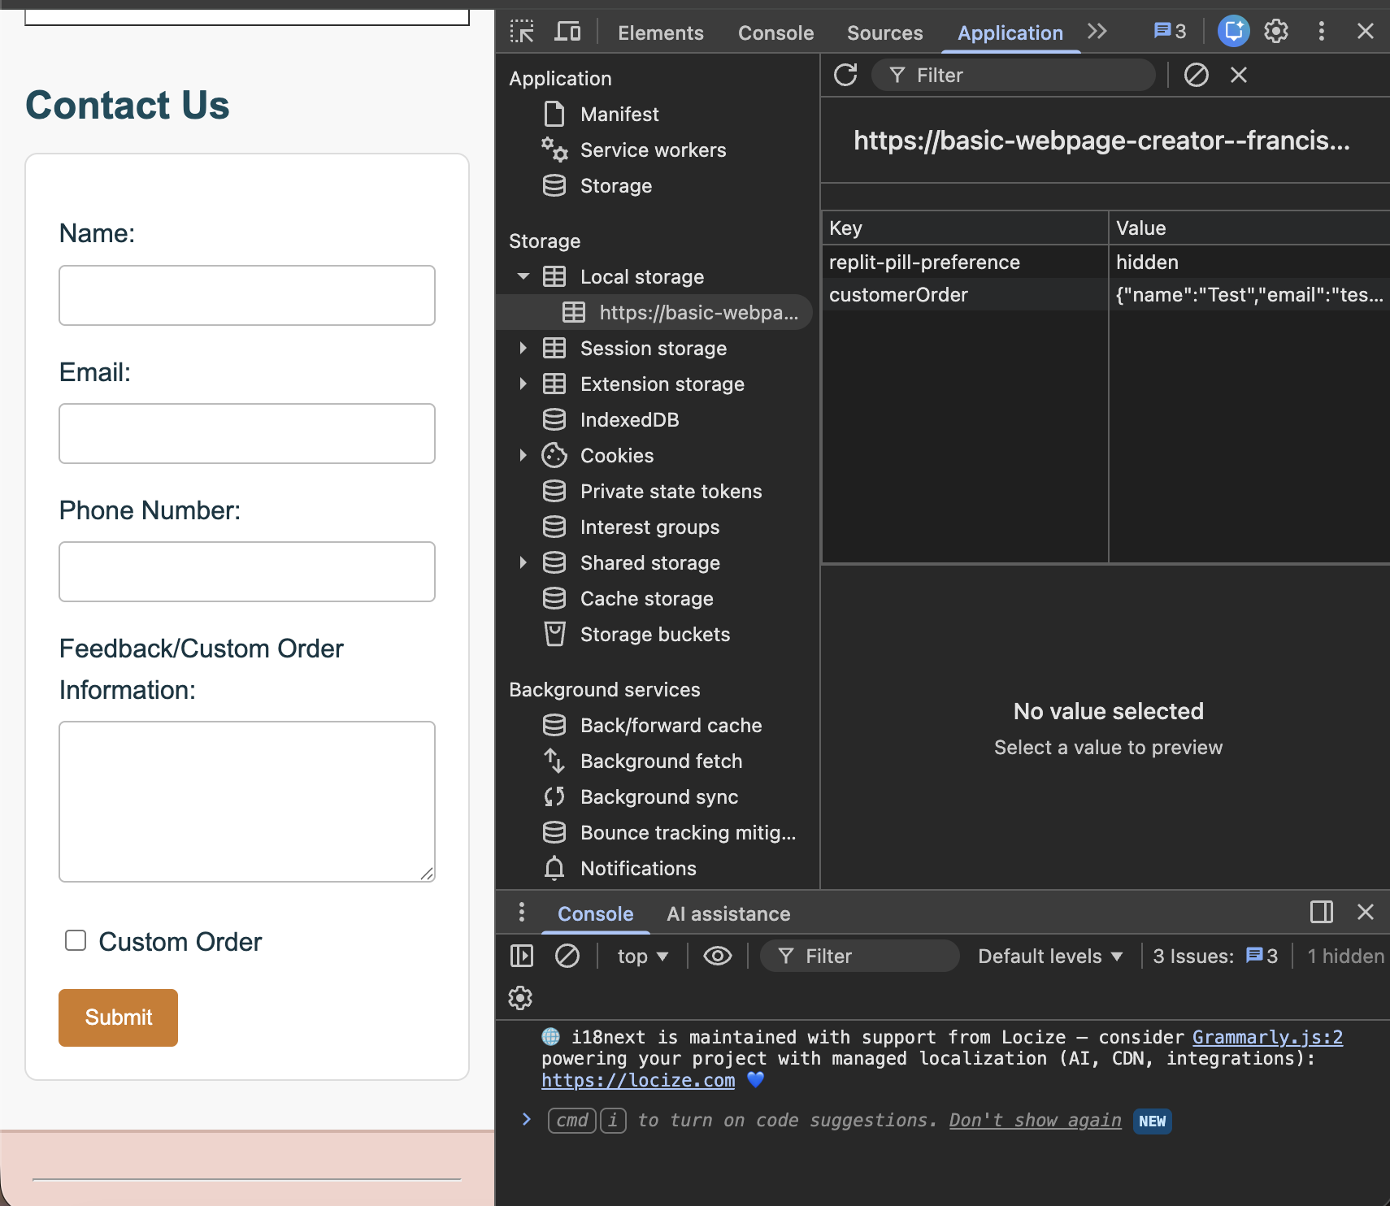

This screenshot shows the localStorage data after submitting the contact form on the About Us page. The customerOrder key stores the submitted customer information and custom order details as a JSON object, confirming that the form data is successfully saved in localStorage.

Custom Order Information Analysis

When the user submits the form on the About Us page, JavaScript collects the input values and stores them in localStorage as a JSON object. This allows the data to persist in the browser even after the page is refreshed. The form includes fields for name, email, phone number, feedback, and custom order selection.

Testing and Error Reporting
Recorded the details of the error from the IDE here. None
Describe what I attempted in order to fix the error.
While testing the code, I first had an issue where the cart modal did not show the stored items because the button IDs in the HTML did not match the IDs referenced in JavaScript. I corrected the ID names so the event listeners could attach properly. I also verified that sessionStorage was updated after each Add to Cart click and became empty after using Clear Cart and Process Order. On the About Us page, I tested the form submission and confirmed that the customer information was saved correctly in localStorage. After these fixes, the website functioned as expected.

